 | DEPARTMENT OF COMPUTER ENGINEERING
Experiment No.1
Semester | T.E. Semester VI
Subject | ARTIFICIAL INTELLIGENCE (CSL 604)
Subject Professor In-charge | Prof. Avinash Shrivas
Assisting Teachers | Prof. Avinash Shrivas

Student Name | Deep Salunkhe
Roll Number | 21102A0014
Lab Number | 310A

Title:

Water Jug Problem (AI)

Theory:

The water jug problem is a classic puzzle that involves two jugs with known capacities, and the task is to measure a specific amount of water using these jugs. The jugs can be filled, emptied, and water can be transferred between them.
Objective:
In this program, the objective is to make the 4g jug contain exactly 2g of water.
Jug Capacities:
- 4g Jug (g_4): Represents the jug with a capacity of 4 units.
- 3g Jug (g_3): Represents the jug with a capacity of 3 units.
Program Explanation:
Initial State:
The program starts with both jugs empty (0g in both).

Program Code:

#include <iostream>
#include <unordered_map>
#include <vector>
using namespace std;

// Define a custom hash function for pairs of integers
struct pair_hash {
template <class T1, class T2>
size_t operator()(const pair<T1, T2>& p) const {
auto hash1 = hash<T1>{}(p.first);
auto hash2 = hash<T2>{}(p.second);
return hash1 ^ hash2;
}
};

// Function to check if the current state is the goal state
bool isGoalState(int g_4, int g_3) {
return g_4 == 2; // Goal state: 4g jug has 2g water, 3g jug is empty
}

// Function to solve the water jug problem
void solveWaterJugProblem() {
// Map to store the next states for each current state
unordered_map<pair<int, int>, pair<int, int>, pair_hash> nextStateMap;
vector<string> path; // Path to store the solution steps
int g_4 = 0, g_3 = 0; // Initial state

// Generate the nextStateMap based on the rules of the problem
nextStateMap[{0, 0}] = {0, 3};
nextStateMap[{0, 3}] = {3, 0};
nextStateMap[{3, 0}] = {3, 3};
nextStateMap[{3, 3}] = {4, 2};
nextStateMap[{0, 2}] = {2, 0};
nextStateMap[{2, 0}] = {2, 3};
nextStateMap[{2, 3}] = {4, 1};
nextStateMap[{4, 1}] = {1, 0};
nextStateMap[{1, 0}] = {1, 3};
nextStateMap[{1, 3}] = {4, 0};
nextStateMap[{4, 0}] = {2, 0};
nextStateMap[{4, 2}] = {0, 2};

// Iterative process to find the solution
while (!isGoalState(g_4, g_3)) {
// Print the current state
cout << "Prev State: [" << g_4 << ", " << g_3 << "] => ";

// Get the next state from the map
auto nextState = nextStateMap[{g_4, g_3}];

// Print the next state
cout << "Next State: [" << nextState.first << ", " << nextState.second << "]" << endl;

// Update the current state
g_4 = nextState.first;
g_3 = nextState.second;
}

// Print the final state
cout<<"Goal reached"<<endl;
}

int main() {
cout << "Let's start the water jug problem\n";
cout << "Task: make 4g jug have 2g water\n";

// Solve the water jug problem
solveWaterJugProblem();

return 0;
}

Output:

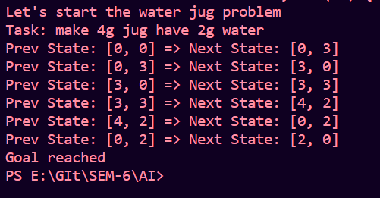

Conclusion:

The water jug problem is a classic example of problem-solving using basic operations such as filling, emptying, and transferring. The provided C++ program solves the problem and using the state mapping logic

